

2nd Annual Champaign Go Red For Women Luncheon

~ featuring Ms. Jennie Garth ~

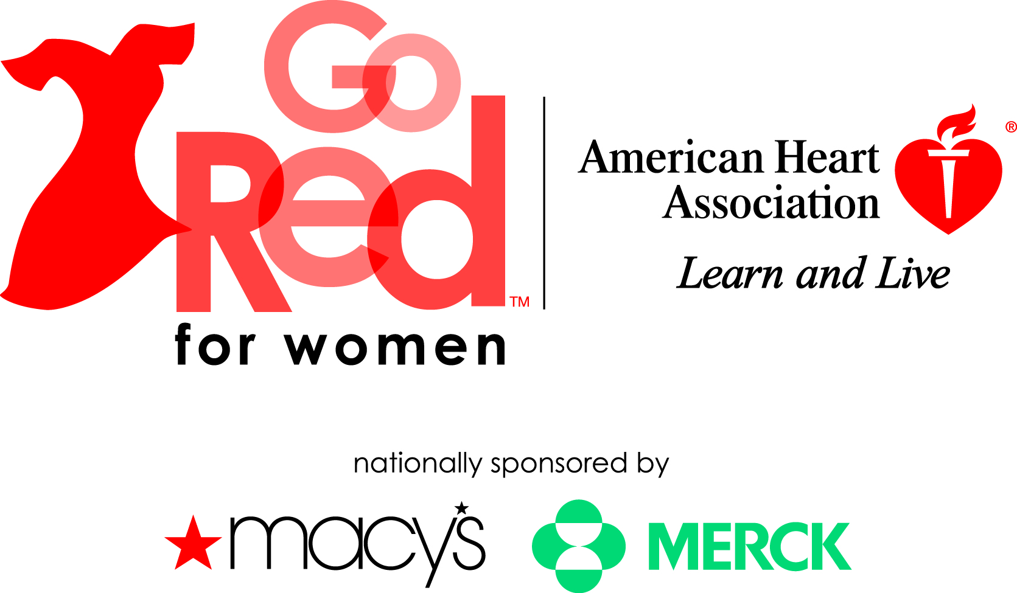

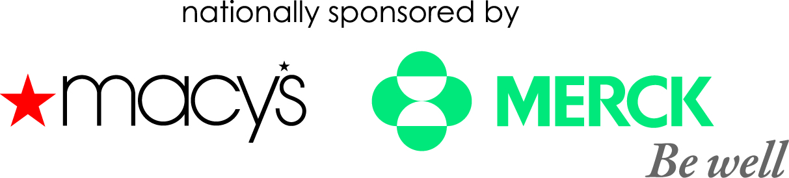

**Champaign Luncheon Signature Sponsor:**

Champaign County native and National Go Red for Women spokesperson



Thursday, May 26, 2011

i-Hotel & Conference Center

Chair: Donna Greene, *President & CEO Busey Wealth Mgmt.*

Sponsorship Opportunities

**Go Red For Women History**

In February 2004, the American Heart Association launched Go Red For Women, a nationwide initiative designed to raise women’s awareness of their risk of heart disease, communicate the simplicity of risk reduction and create a compelling call to action that drives women to take control of their health. Go Red For Women provides knowledge and tools to empower women to make positive changes in their lives that may help reduce their risk of heart disease and stroke.

**Go Red For Women Overview**

Originally, we set out to raise awareness among women that heart disease is their number one killer and to create an emotional appeal for the issue of women and heart disease. As awareness has risen, our focus has shifted to action. The Go Red for Women guidelines are the foundation of all of our messaging. We aim to translate the science into clear, actionable steps for women!

**Why Go Red?**

***Heart disease is the No. 1 killer of women.***

* A woman dies every minute from cardiovascular disease, claiming the lives of over 460,000 women every year.
* While 1 in 30 American women die of breast cancer, almost 1 in 3 die from cardiovascular disease.
* 43 million American women are living with cardiovascular disease (CVD).
* Only 57% of American women recognized that heart disease is their leading cause of death.

**Objectives of Go Red**

* Continue to raise awareness of women’s risk of heart disease, positioning Go Red as #1 women’s heart-health brand and red dress icon as symbol of women and heart disease
* Drive behavior change by engaging more women in Go Red and increasing the number of women who know their personal risk of heart disease.
* Drive treatment to the AHA Women’s Guidelines
* Expand offerings to reach diverse audiences
* Increase fundraising support for education, outreach, and research

**Components of Go Red For Women**

**Go Red REGISTRATION:** Signing up for the movement includes a monthly e-newsletter filled with heart-healthy tips, plus invitations to events in your area, as well as access to Go Red merchandise, special programs and more.

**Heart CheckUp**: An online tool that provides a 10-year, personal heart disease risk assessment. Once completed, women take their CheckUp results to their healthcare provider and develop a personal health plan that matches their needs.

**Consumer Education:** The AHA has compiled materials for consumers such as a cookbook, brochures, wallet cards, bookmarks, posters, Web alerts, screen savers, e-cards, etc.

**Physician resources:** The American Heart Association works with healthcare professionals to provide new prevention guidelines, patient reports, red dress pins, wallet cards, online monthly newsletters and more.

**National Wear Red Day:** On the first Friday in February (2/4/11), the AHA encourages women to wear red – whether it is a red dress, a red t-shirt, a red dress pin or red lipstick. Show the world you passionately support Go Red For Women!

**GO RED FOR WOMEN LUNCHEON:**

The Luncheon is themed around sisterhood and inspiration. It’s a life-changing experience that focuses on four areas of interest in the fight against heart disease in women: heightening awareness of the issue, passionately honoring local survivors, celebrating relationships with friends and generating funds to support education and research.

**GO RED BETTER U:**

Welcome to the Free Makeover that could Change Your Life. Improve your overall health in just 12 weeks. The Go Red BetterU courses provide guidance to help transform your overall health from the inside out. You’ll learn smart strategies and gain new information on improving and maintaining your health, along with the encouragement and advice of online coaches. Each week will focus on a different area to follow for a complete heart makeover. Live longer and stronger by taking 12 weeks to invest in your health. **Our Hearts. Our Choice. Choose a BetterU.**

**PASSION:**

Go Red For Women is looking for women to share their heart stories and the choices they make to live a heart-healthy lifestyle, empowering others by example. Women who share their stories have the chance to become a spokesperson for the cause – representing Go Red For Women in marketing materials, at events, on [GoRedForWomen.org](http://www.goredforwomen.org) and possibly at a national level. Casting Calls will be held locally to hear some the passionate stories from real women living in our community.

**FUN AND SOCIAL:**

Cardiovascular disease kills over 432,000 women each year -- about one every minute. Yet studies show that only 21% of women view heart disease as their greatest threat, even more than cancer! Choose to Live, a 30-minute NBC TV special that premiered in 2009, teaches women how to make small – and lifesaving – choices for their hearts. Featuring Champaign County native **Jennie Garth** along with Hoda Kotb, the show raises awareness through personal stories of four women living and their stories of heart disease. This TV special may be played for a group of ladies from the area at a **Viewing Party and at numerous Lunch and Learn’s**.

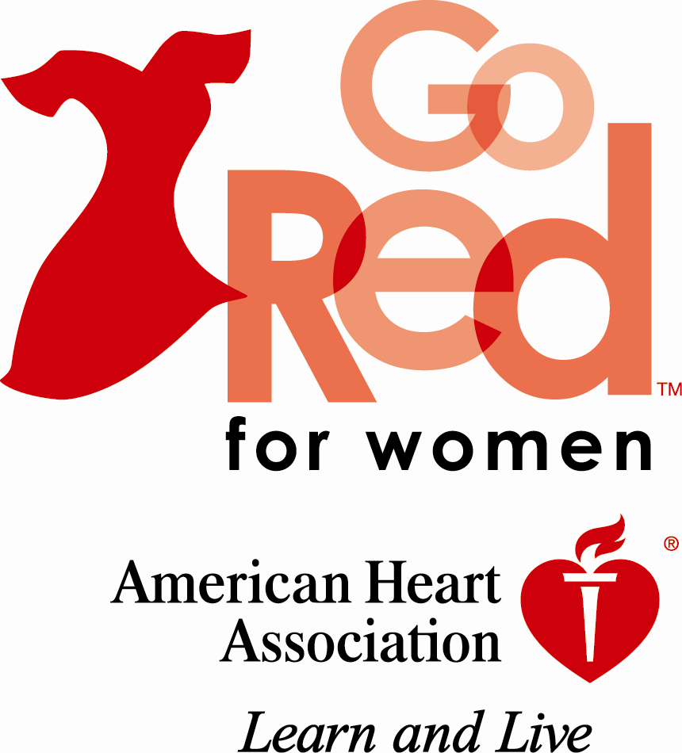**Go Red for Women 2011 Partnership Year-Round**

**$10,000 Sponsorship Level**

|  |
| --- |
| **Marketing Benefits: CHOOSE ONE** |
| 1. **Go Red Viewing Party:** Communities across the country will be hosting **Viewing parties** for individuals to see the power of the movement and to learn more about their own Heart Health! Host a viewing party at your business and invite as many or as few as you’d like. 2. **Casting Call:** Host an opportunity for local women to share their stories of heart disease or be the top sponsor of the event to be held at Macy’s. Jennie Garth will voice the promotional commercials for this event. 3. **Hoda Jennie small.jpgGo Red Better U:** The Go Red BetterU courses provide guidance to help transform your overall health from the inside out. Select members from your organization to take part in a free 12 week makeover that could change their life! We will feature these ladies at the luncheon event. |
| **Opportunities to leverage your Partnership** |
| * Opportunity to host a booth at the event * Opportunity to host an event at the location of your choice * Two (2) tables of ten (10) at luncheon with table signage * Opportunity to have up to one (1) booth in expo area * Opportunity to provide promotional item for gift bag (American Heart Association approval required) * Opportunity for **30-day activation** rights to co-brand with Go Red For Women * Opportunity to be recognized on local Go Red For Women site with link to company site – [www.champaigngoredforwomen.org](http://www.champaigngoredluncehon.org) * Opportunity to be recognized in Powerpoint presentation at the event * Opportunity to be recognized on local Go Red For Women local Facebook site * Logo and sponsorship recognition on specific sponsored asset via collateral materials (time sensitive) * Use of proclaimer statement: “Made possible by”, “Brought to you by”, “Provided by”, “Provided courtesy of” * One (1) full page of recognition in event program * The COMPANY will be acknowledged the day of the event from the podium |
| **Investment** |
| **$10,000** |

**Go Red for Women 2011 Partnership Year-Round**

**$7,500 and $6,000 Sponsorship Levels**

|  |
| --- |
| **Marketing Benefits: CHOOSE ONE** |
| 1. **Faces of Heart*:*** Sponsor bookmark that features local, female heart disease survivors. The survivor, photo and design will be provided. The quantity, printing and additional distribution (schools, library, public health dept.) will be up to the sponsor. 2. **Picture and a Promise:** Host walk-up digital photo-booth at Luncheon and other relevant, year-round events to visually capture women making a commitment to a healthier lifestyle. Opportunity to mail a “heart healthy” message and printed frames with follow-up materials to participants. Photos will be taken with Jennie Garth.   SOLD to Busey   1. **CPR Anytime Sponsor:** Increase local survivorship of heart-related emergencies through distribution of CPR self-training kits to targeted audience in the community. Sponsor logo will be present on kits. Insert introduction letter from sponsor to accompany kits. (25 kits will be provided and the distribution can be determined by the sponsor). 2. **232323232%7Ffp6325%3B%3Enu%3D326%3A%3E%3B%3C6%3E%3B%3A%3A%3EWSNRCG%3D347287757332%3Bnu0mrj.jpgPicture and a Promise1.jpgAsk the Expert:** Host a panel of four experts on relevant topics to the movement (two “experts” will come from Signature Sponsor if health care related) |
|  |
| * Opportunity to host a booth at the event * Ability to provide volunteers (experts, survivors, staff, etc.) for specific sponsored asset (with American Heart Association approval) * One (1) table of ten (10) at luncheon with table signage * Opportunity to have one (1) booth in expo area * Opportunity to be recognized on local Go Red For Women website * Opportunity to be recognized on local Go Red For Women local Facebook site * Opportunity to be recognized in Powerpoint presentation at the event * Logo and sponsorship recognition in event program, and on specific day of event collateral materials (time sensitive) * Use of proclaimer statement: “Made possible by”, “Brought to you by”, “Provided by”, “Provided courtesy of” * One (1) half page of recognition in event program |
| **Investment** |
| **$7,500 for Faces of Heart, Ask the Expert and CPR Anytime; $6,000 Picture and a Promise** |

**Go Red for Women 2011 Partnership Year-Round and Day-Of**

**$3,000 Sponsorship Level**

|  |
| --- |
| **Marketing Benefits: CHOOSE ONE** |
| **Year-Round Opportunities:**   1. **Survivor Gallery*:*** Sponsor unique traveling photo exhibit that features local, female heart disease survivors in intimate black and white portraits and features their compelling stories. – multiple opportunities available 2. **Jennie.Go Red.jpgGo Red Heart to Heart (*max of 3 available*):** Host a 30 min. breakout session on a specific topic at the Go Red For Women Luncheon to give women an opportunity to gather and learn together about fun, consumer-friendly topics relevant to the movement. – multiple available   Sold to County Market & Carle (1 left)  **Day of Event Opportunities:**   1. **Speak from the Heart Sponsor:** Sponsor of the keynote passion speaker, Jennie Garth at the Go Red for Women Luncheon 2. **Swag Bag Sponsor:** Goodie bags will be provided to each guest at the Luncheon and you will have the opportunity to provide one item for each bag. |
| **Opportunities to leverage your partnership** |
| * Opportunity to host a booth at the event * One (1) table of ten (10) at luncheon with table signage * Opportunity to provide promotional item for gift bag (American Heart Association approval required) * Opportunity to be recognized on local Go Red For Women website * Opportunity to be recognized on local Go Red For Women local Facebook site * Opportunity to be recognized in Powerpoint presentation at the event * All invitations and collateral material will recognize COMPANY as a $3,000 contributor * Logo and sponsorship recognition in day of event program on day of event collateral materials (time sensitive) * Use of proclaimer statement: “Made possible by”, “Brought to you by”, “Provided by”, “Provided courtesy of” * Receive a ½ page of recognition in event program |
| **Investment** |
| **$3,000** |



**Go Red for Women 2011 Day-Of**

**$1,500 Sponsorship Level**

|  |
| --- |
| **Marketing Benefits:** |
| **Day of Event Opportunities:**   1. **Table Sponsor** |
| **Opportunities to leverage your partnership** |
| * One (1) table of ten (8) at luncheon with table signage * Opportunity to provide promotional item for gift bag (American Heart Association approval required) * Opportunity to be recognized on local Go Red For Women website * Opportunity to be recognized in Powerpoint presentation at the event * Logo and sponsorship recognition in day of event program on day of event collateral materials (time sensitive) |
| **Investment** |
| **$1,500** |

|  |
| --- |
| **Marketing Benefits:** |
| **Day of Event Opportunities:**   1. **Exhibit Sponsor** |
| **Opportunities to leverage your partnership** |
| * Four tickets to attend the Luncheon * Opportunity to be recognized in Powerpoint presentation at the event * Logo and sponsorship recognition in day of event program on day of event collateral materials (time sensitive) * Opportunity to host a booth at the event |
| **Investment** |
| **$1,500** |